**Cloud Project 1**

Developed a full stack project titled **Dropbox** using various AWS services. The application allows users to sign up/sign in and upload/delete their files from the S3 bucket. The users data is stored and maintained in the AWS DynamoDB. An admin page is created to track all the users information. The admin has the right to delete, update and upload files.

Frontend- React

Backend- Node.js

FileStorage- S3 bucket

Sign in/Sign up- AWS Cognito

Database- AWS DynamoDB

1 ) This page allows users to sign in/sign up to their account.

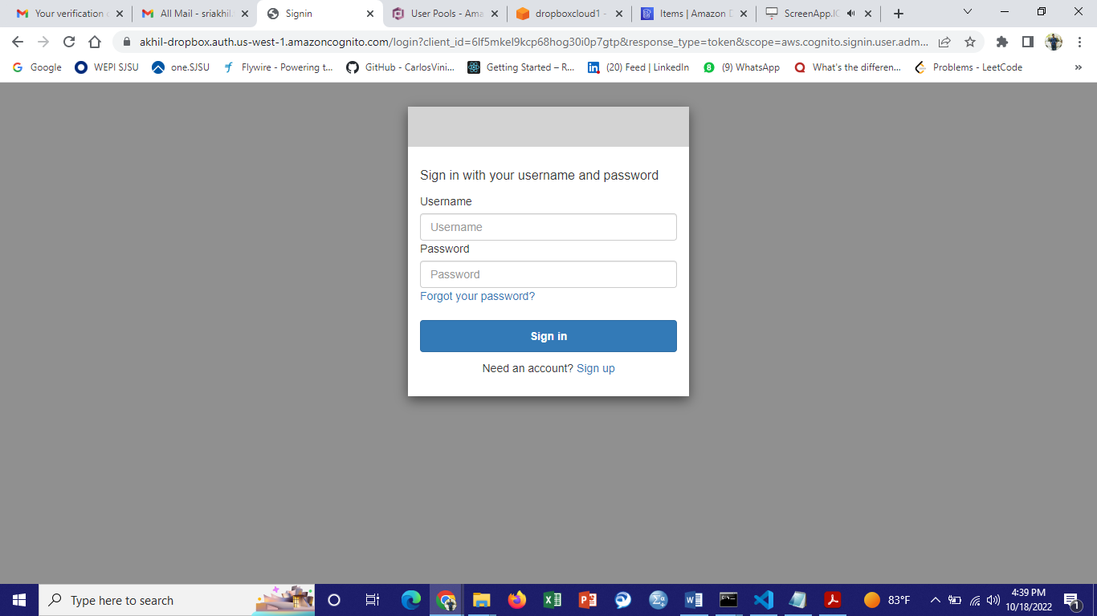

2) In this page the User can upload their files from the local storage to the AWS cloud.

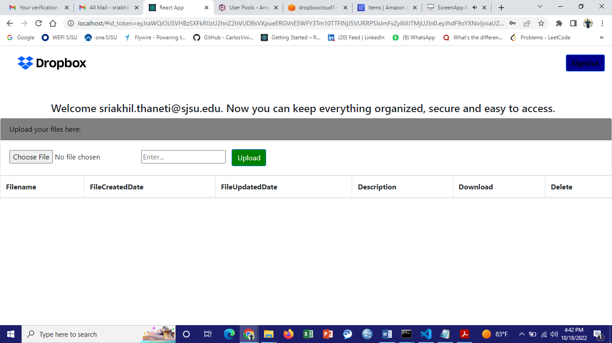

3) Uploading a file to the AWS cloud from [sriakhil.thaneti@sjsu.edu](mailto:sriakhil.thaneti@sjsu.edu)

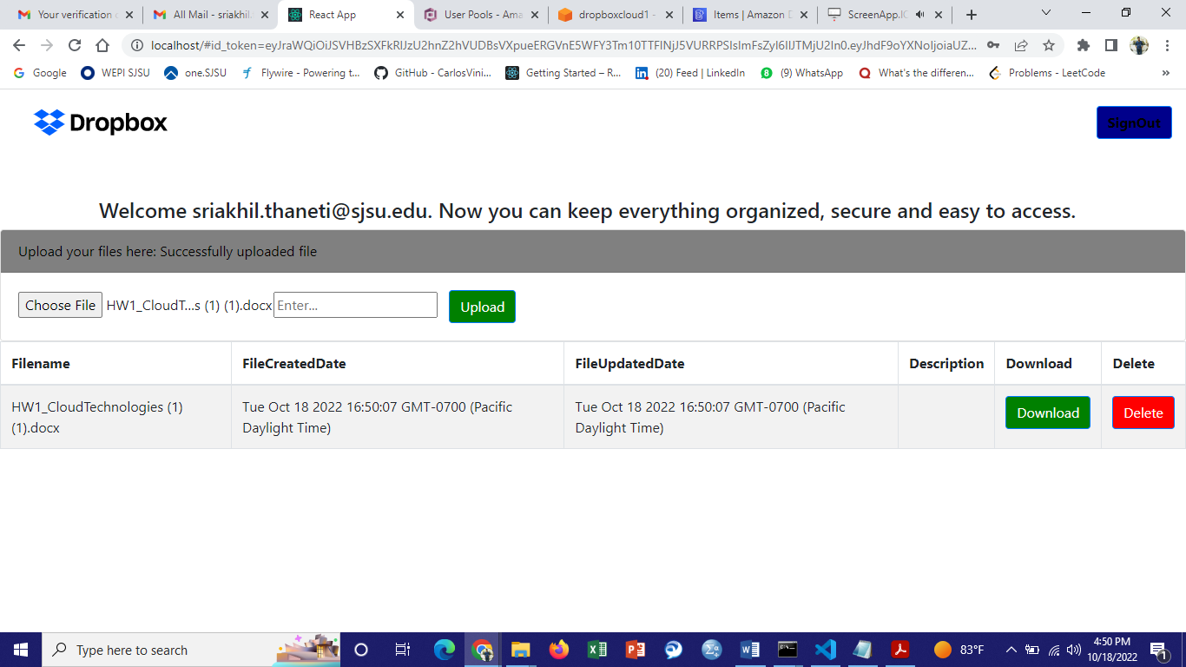

4) File uploaded successfully to the s3 bucket.

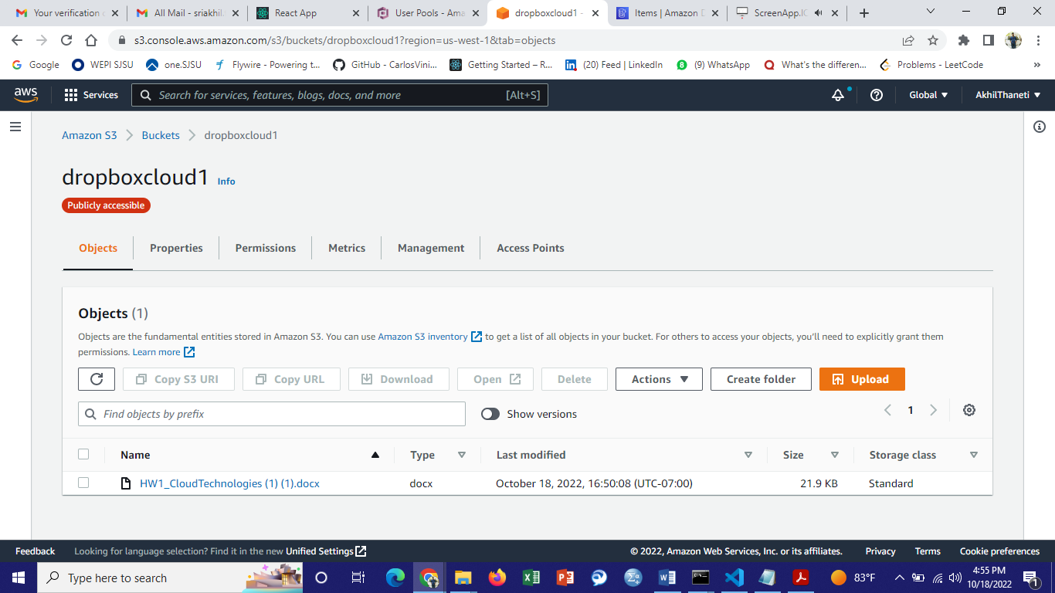

5) User’s data/log is inserted into the AWS DynamoDB.

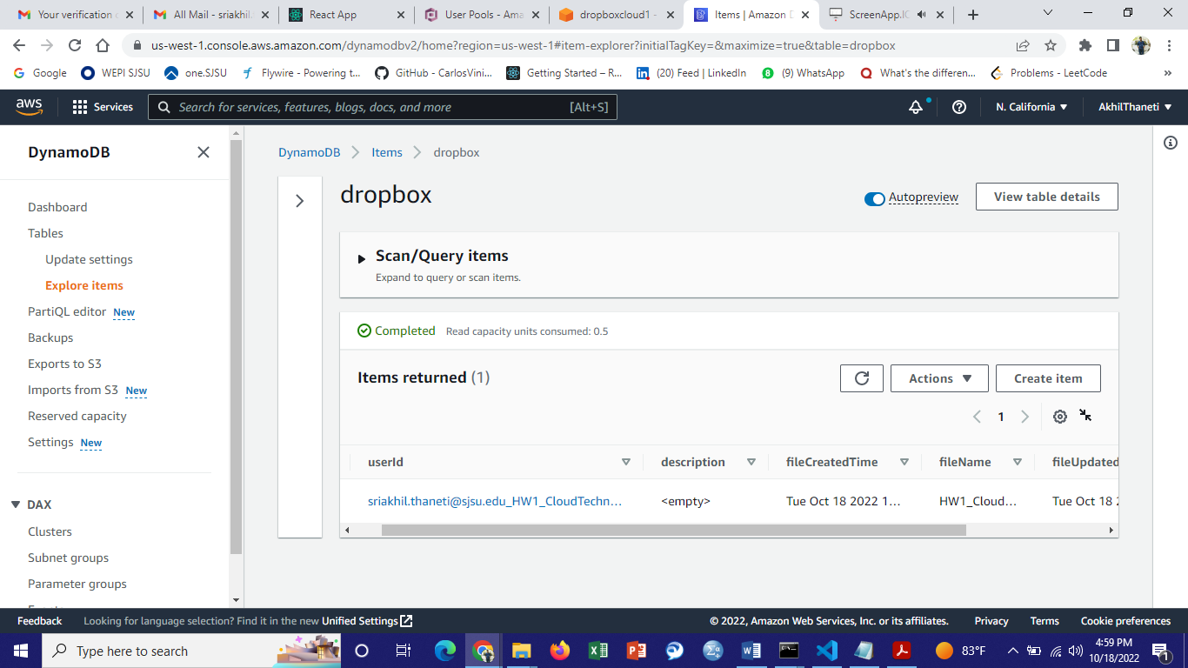

6) Downloading the uploaded file.

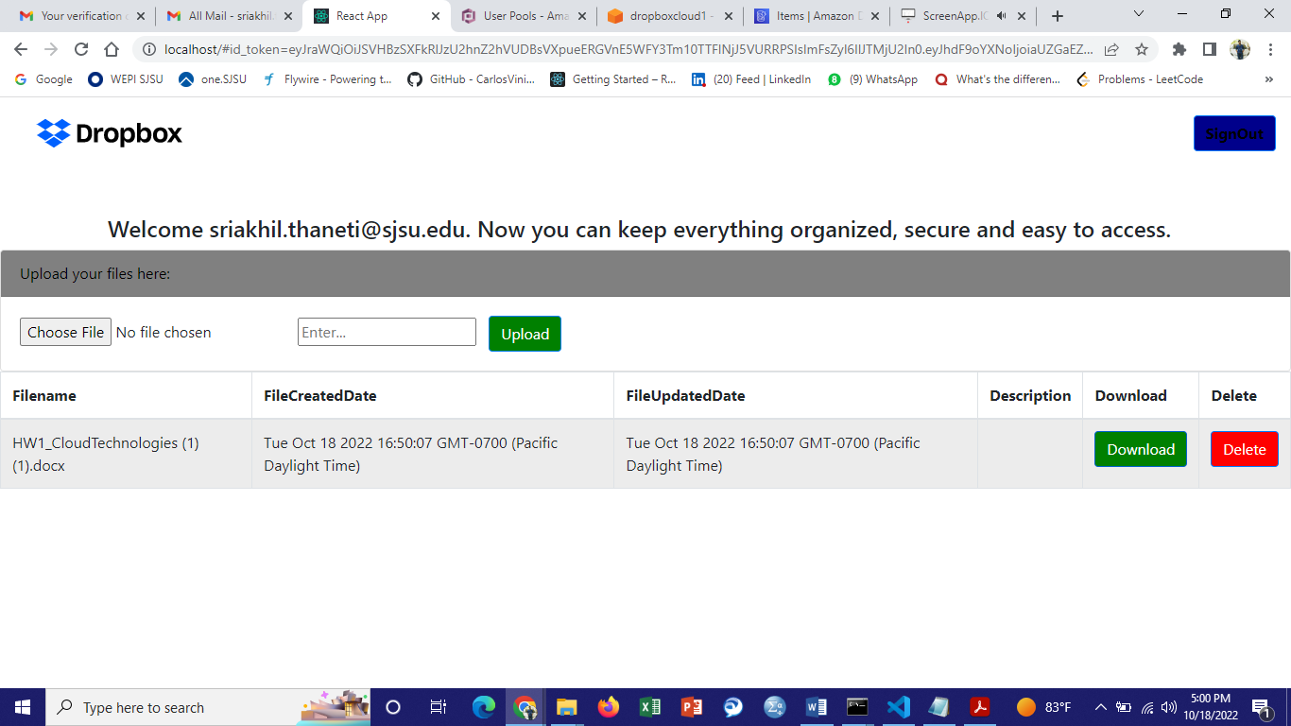

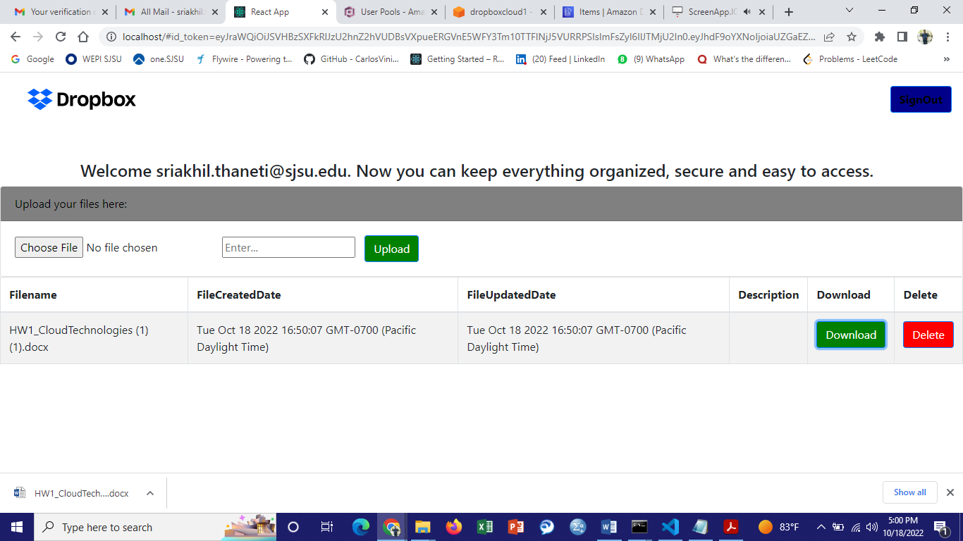

7) File downloaded successfully.

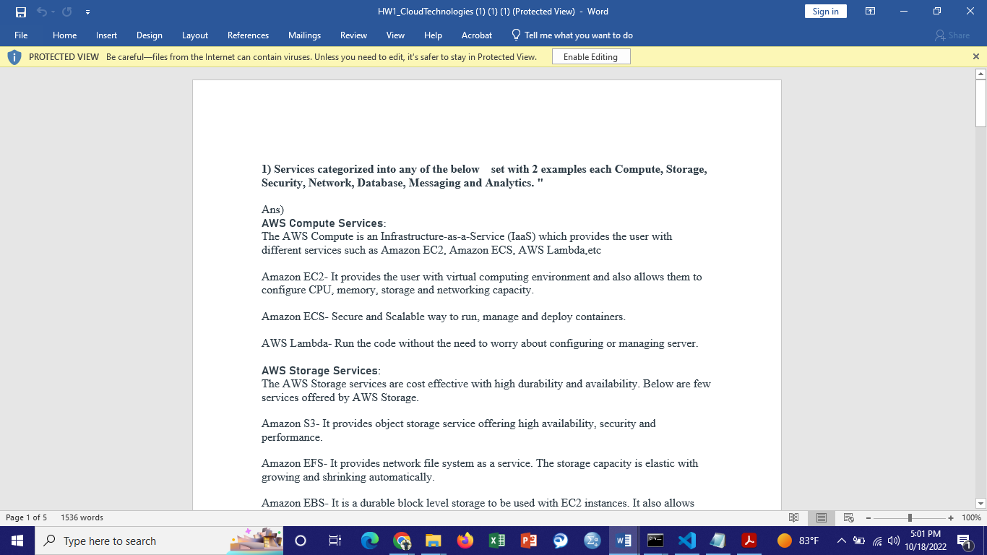

8) Deleted the uploaded file.

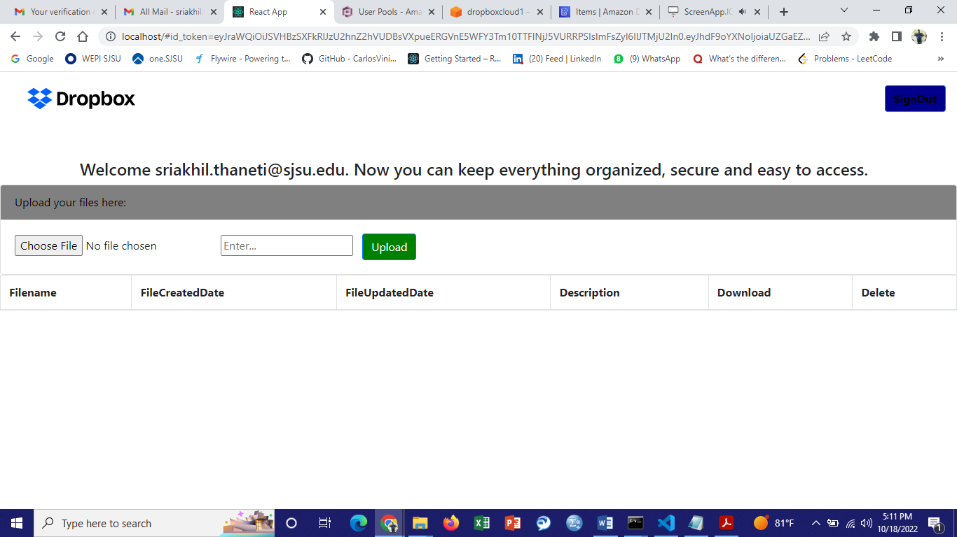

9) The records got deleted in S3 and DynamoDB.

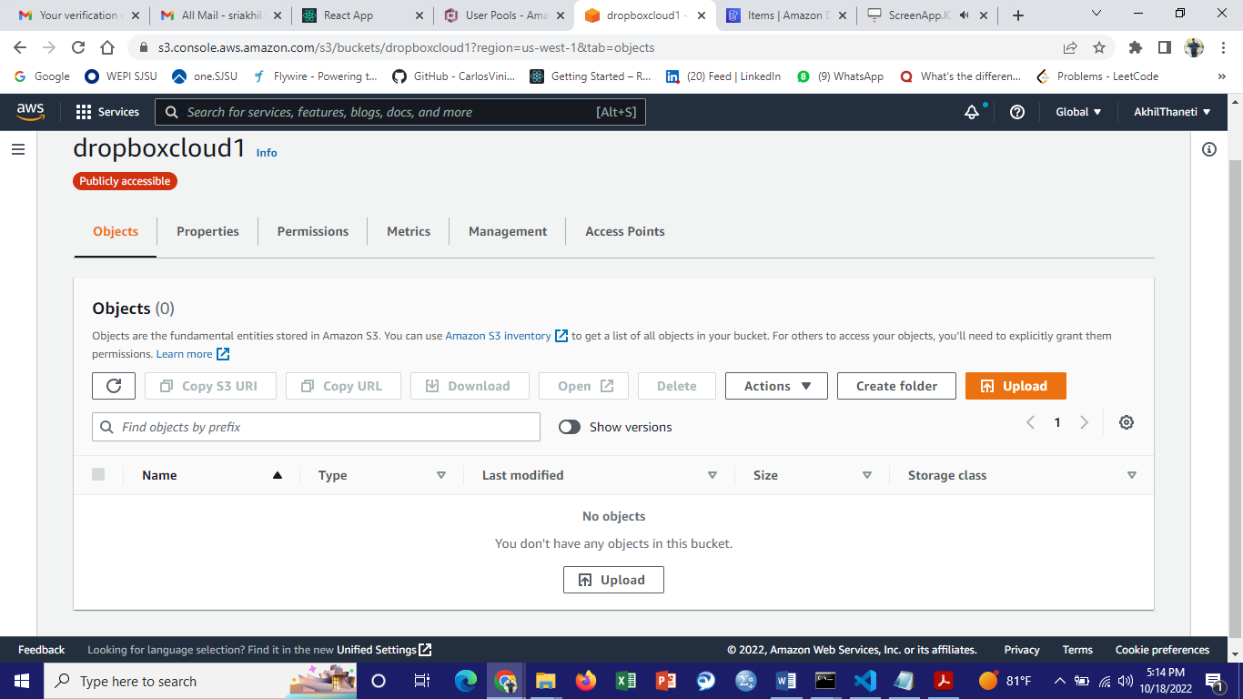

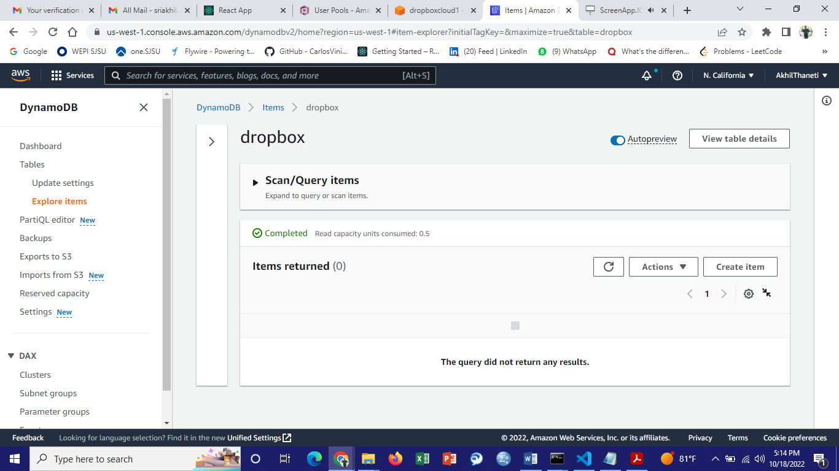

10) Logging into Admin Panel as “admin”. 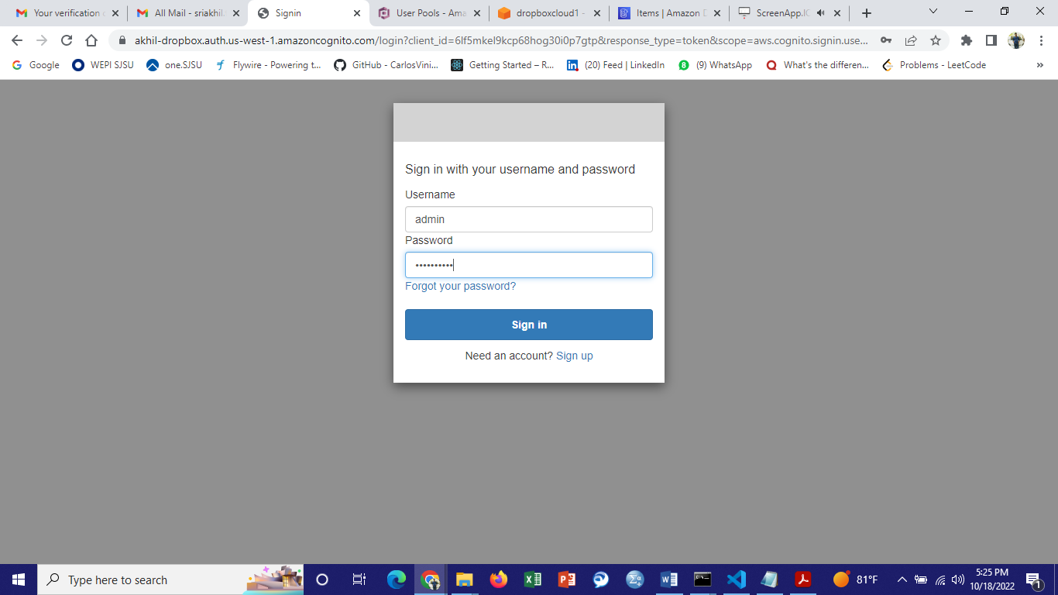

11) The admin has the access to view, update and delete all the files uploaded by the users.

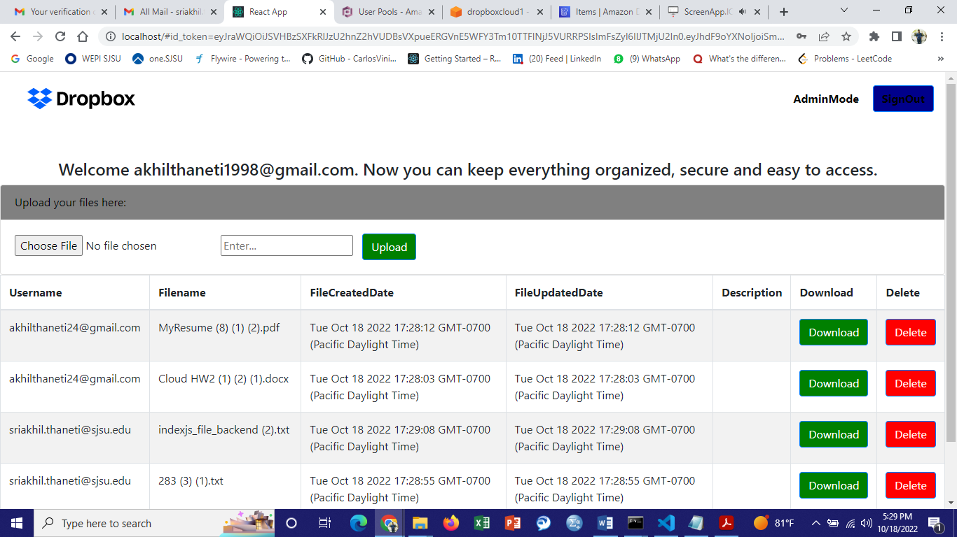

12) Downloading and deleting files.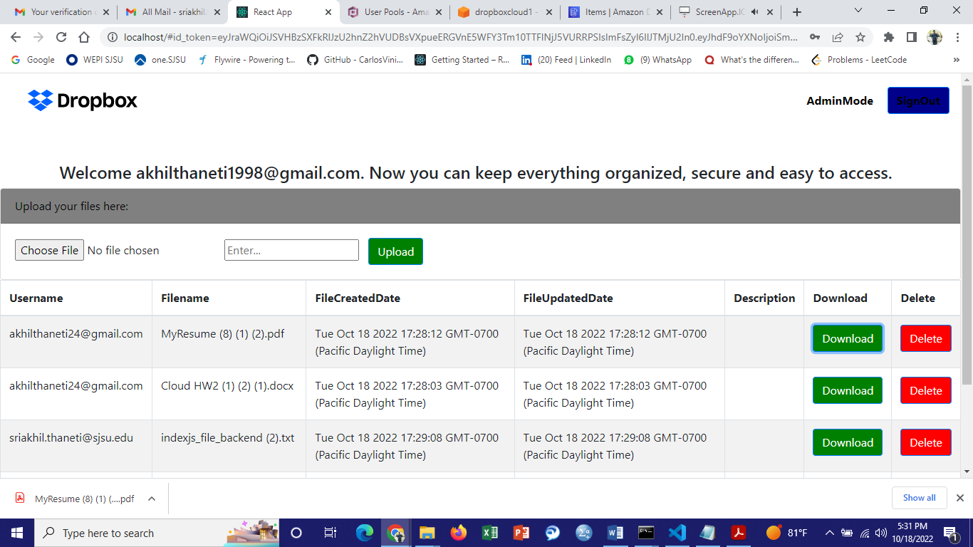

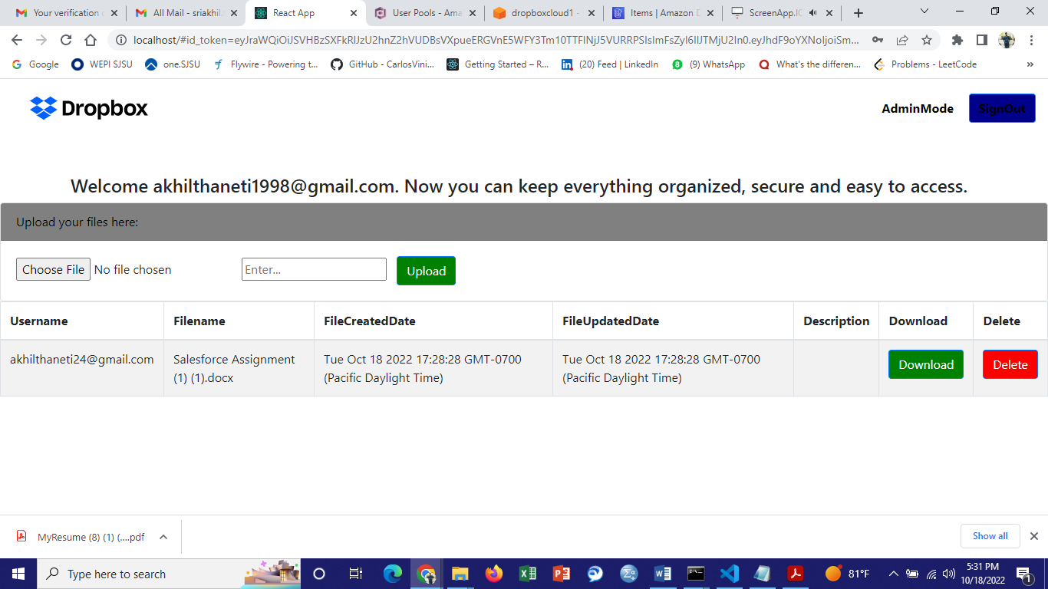

13) Deleted successfully in S3 and DynamoDB.

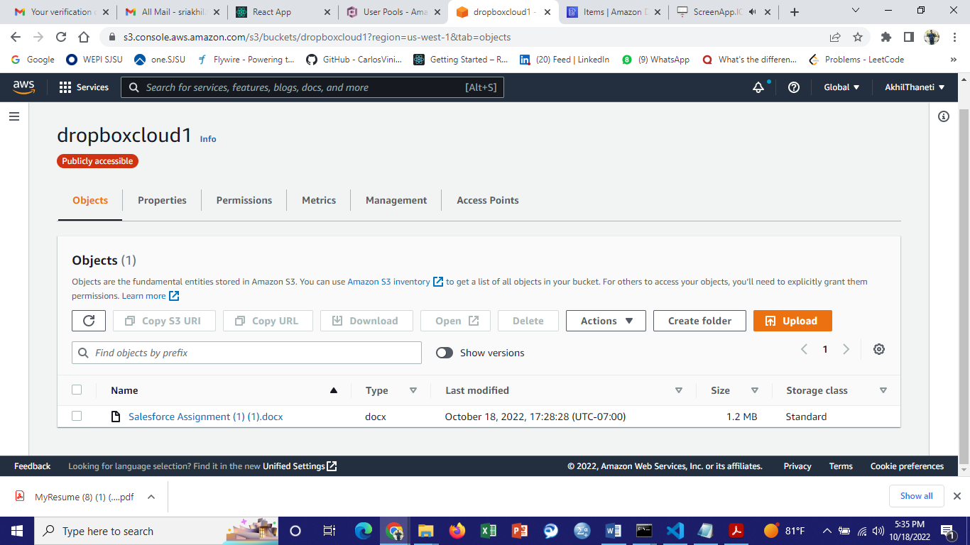

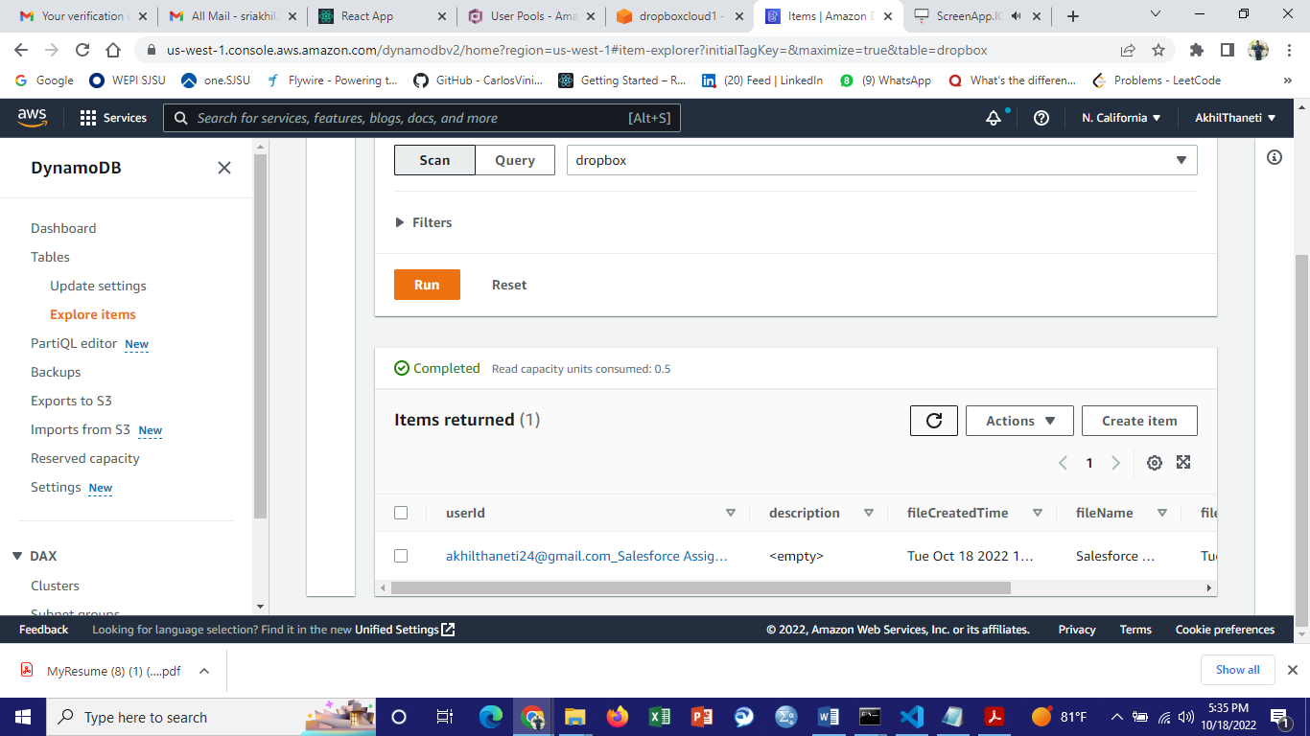

14) Utilized **cloudfront** to download files with low latency.

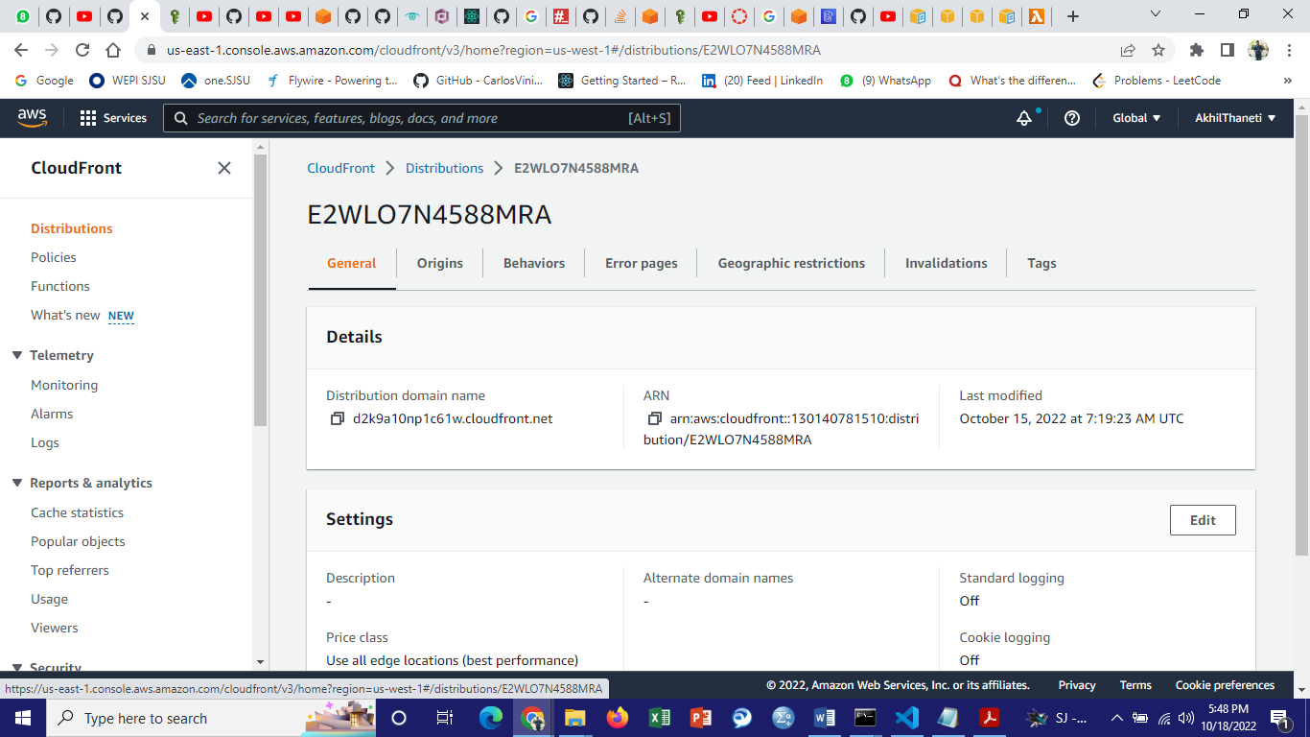

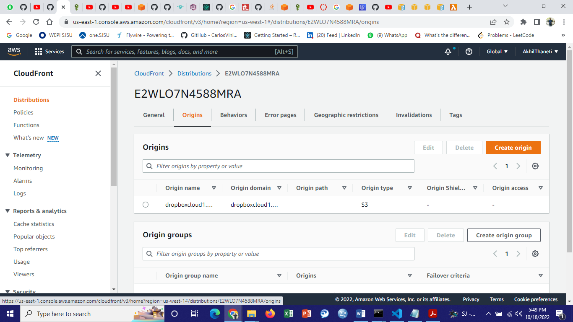

15) Created Multi Region Access points to reduce load on the origin and provide high availability. Replication of files to multiple buckets in different regions provides Disaster Recovery.

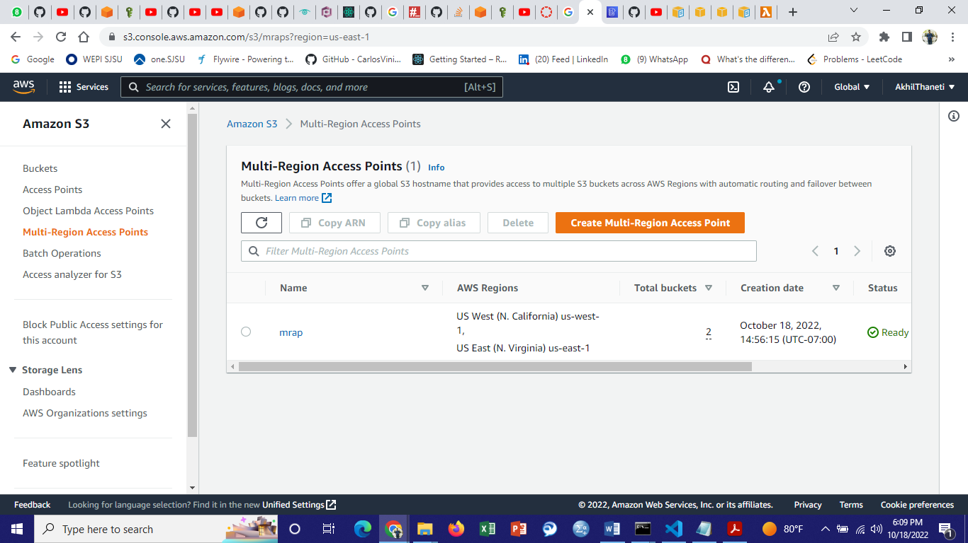

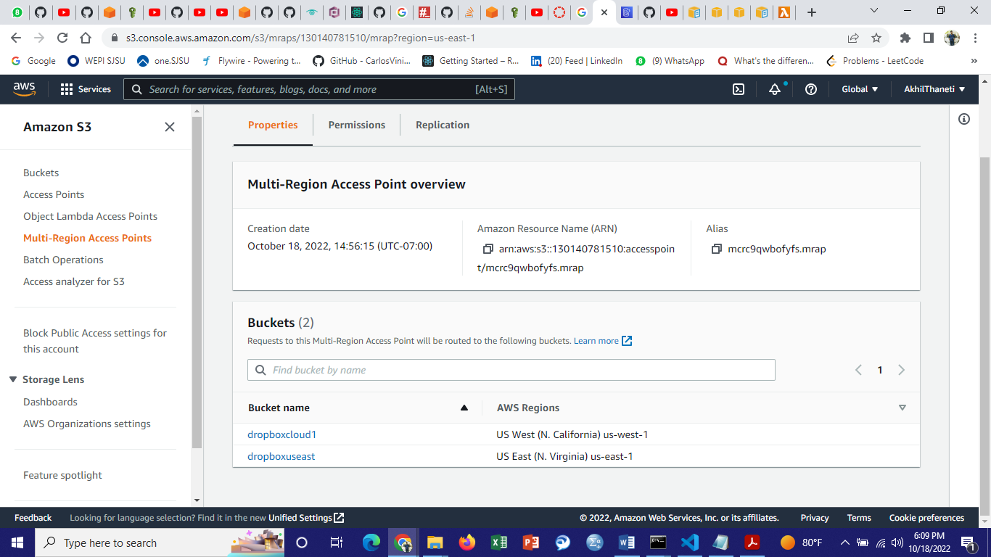

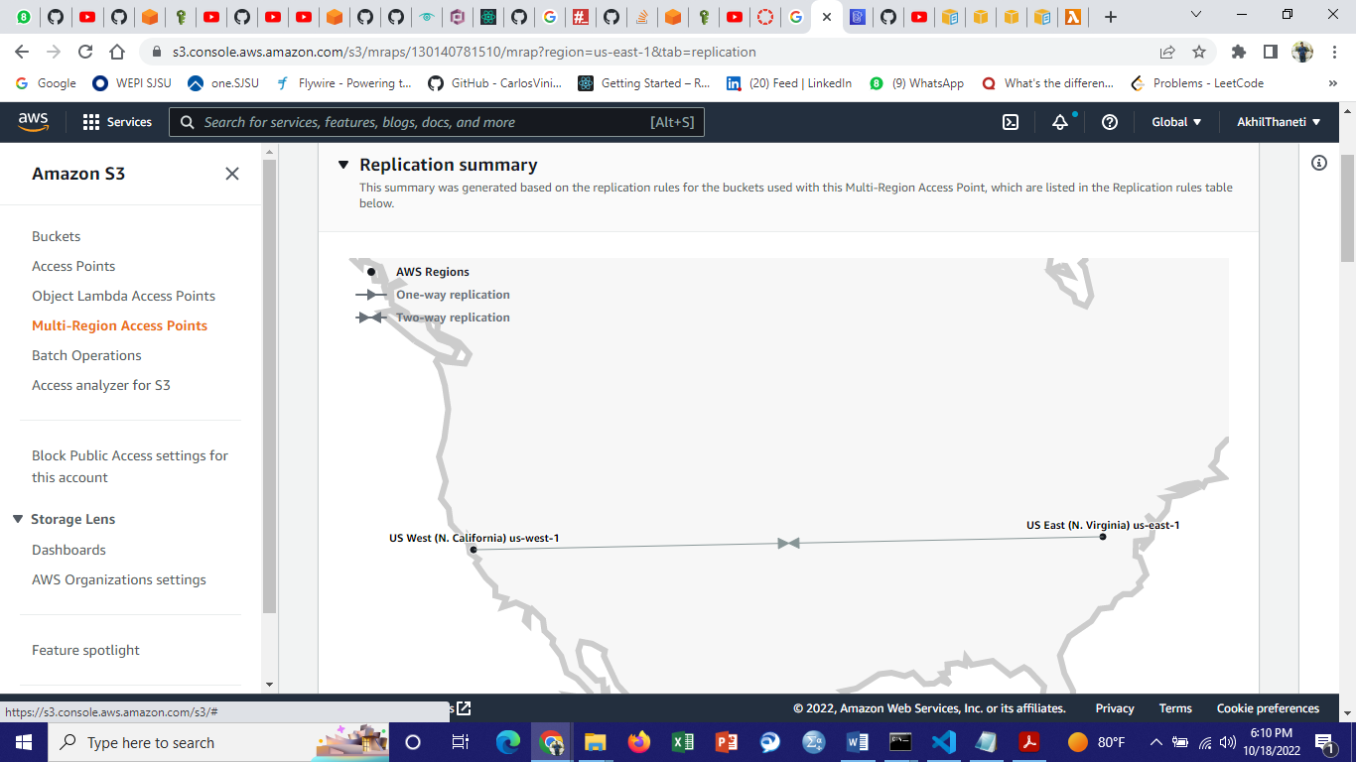

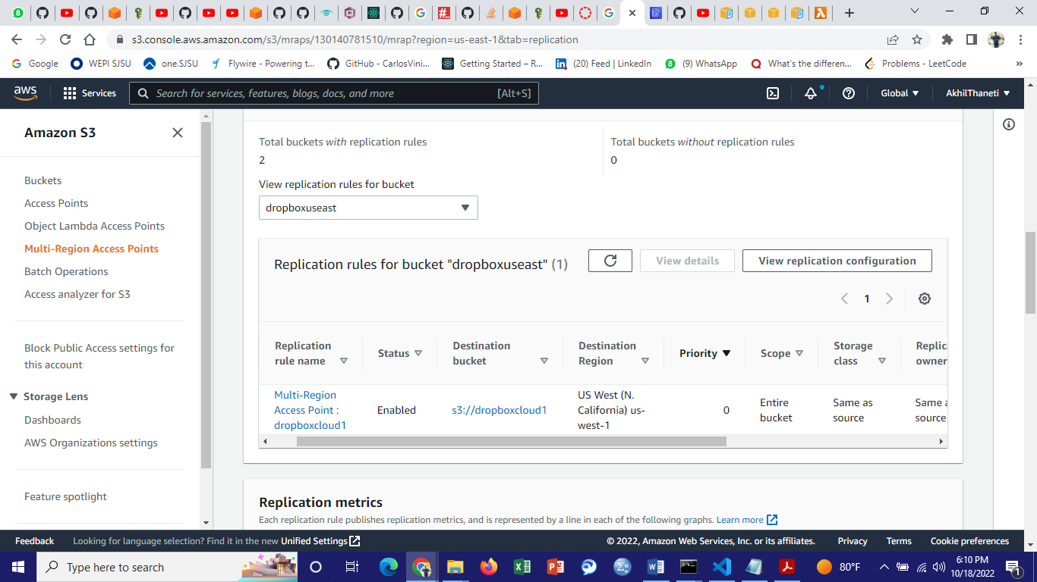

Creating lifecycle rules to move data to different storage groups based on usage and lifetime.

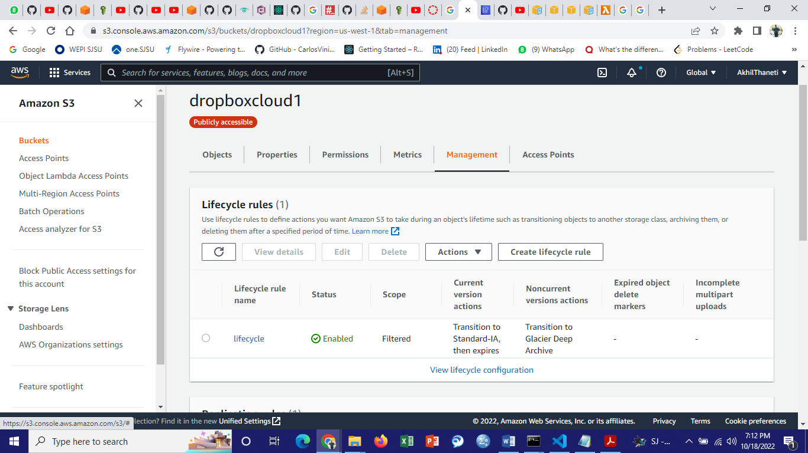

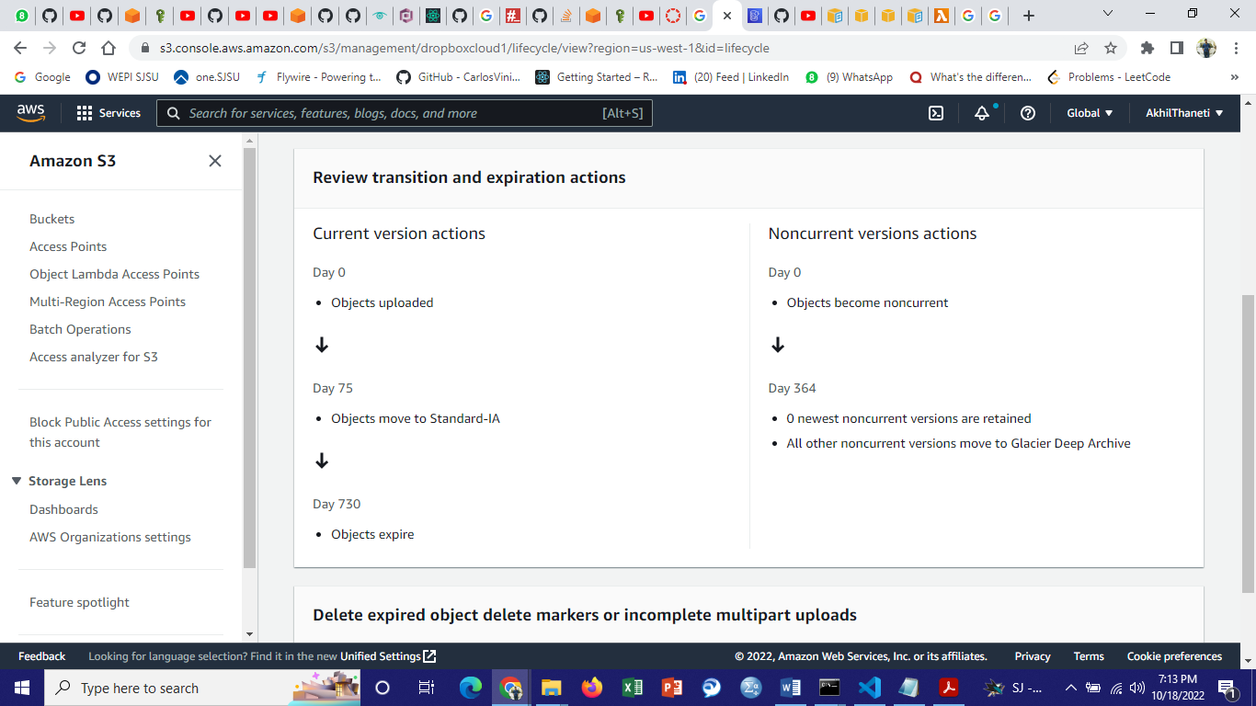

16) Created a Replica for AWS DynamoDB in another region to make it highly available(us east).

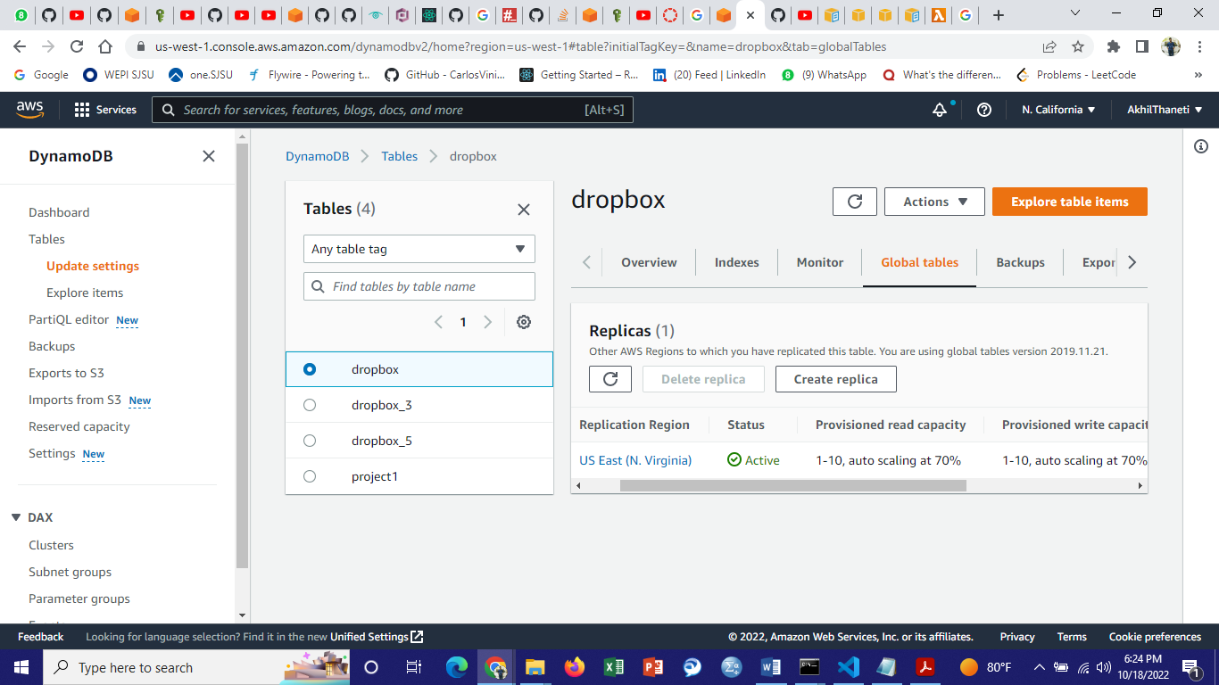

17) Utilized AWS Cognito to store user credentials and provide user authentication and log in.

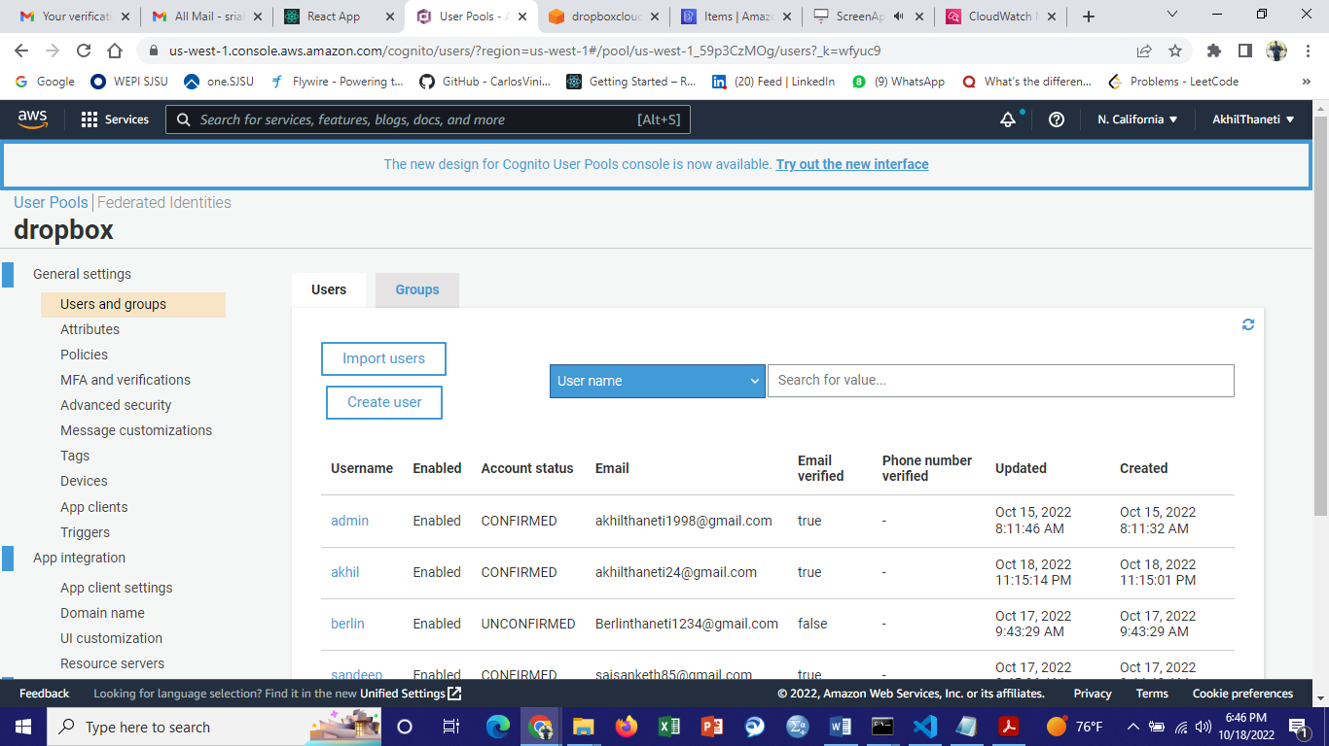

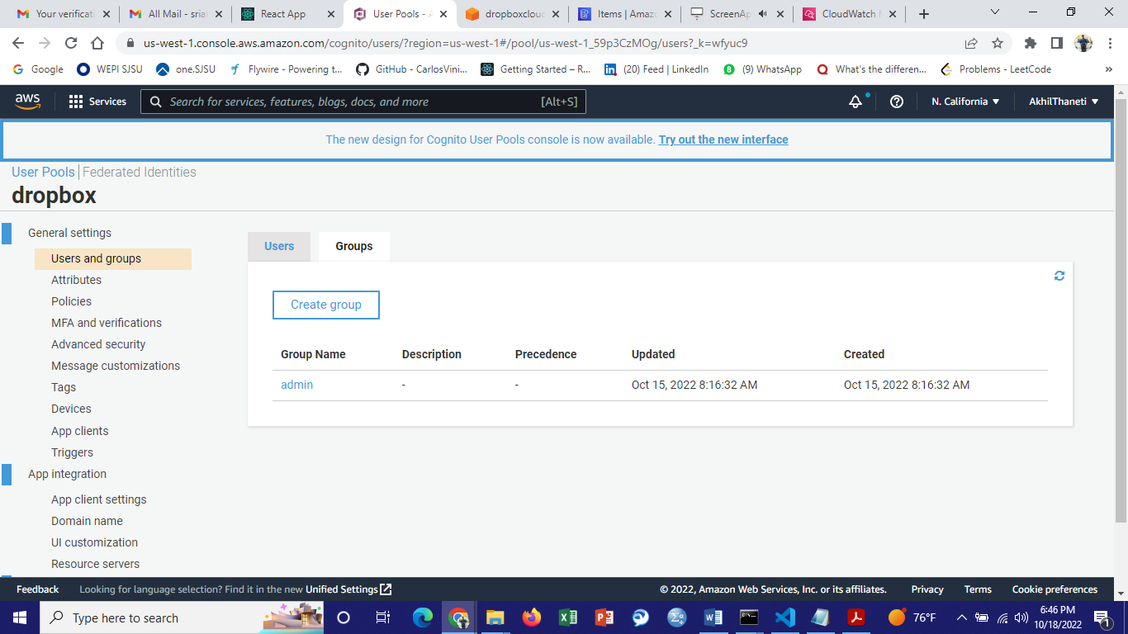

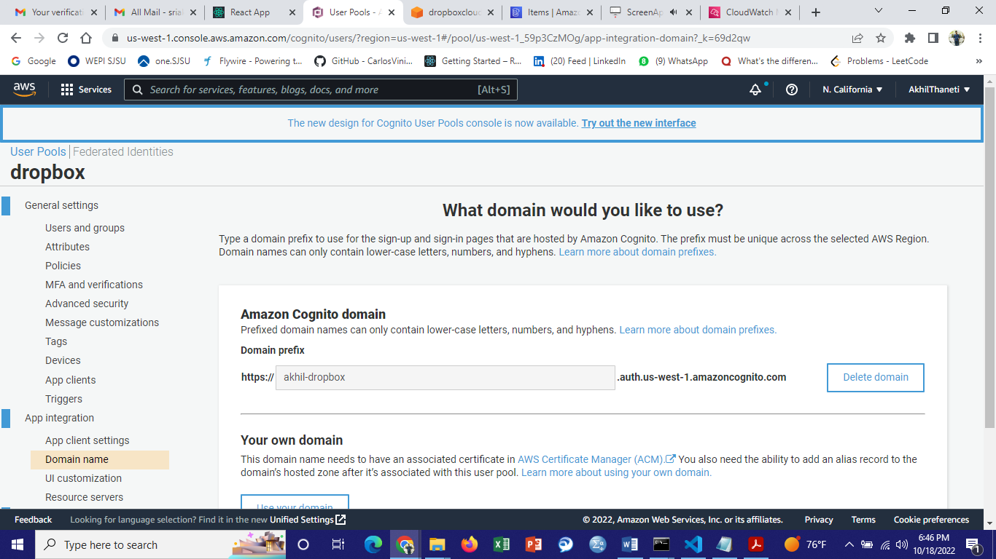

18) Creating an EC2 instance to deploy the dropbox project.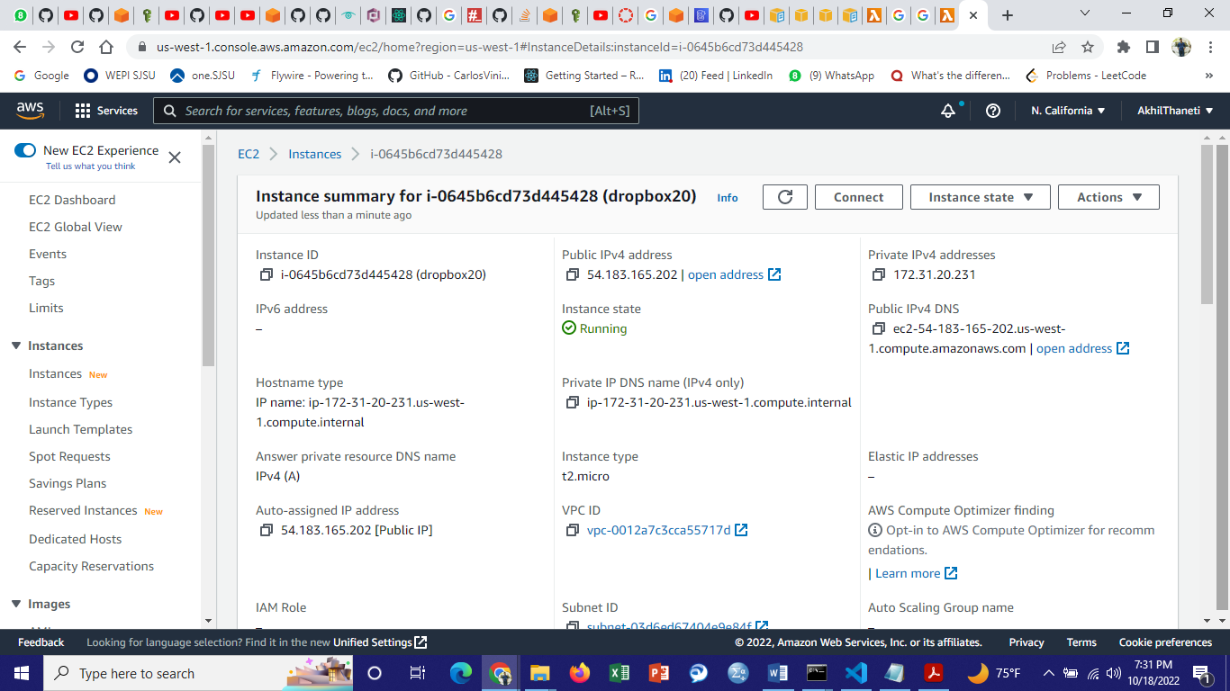

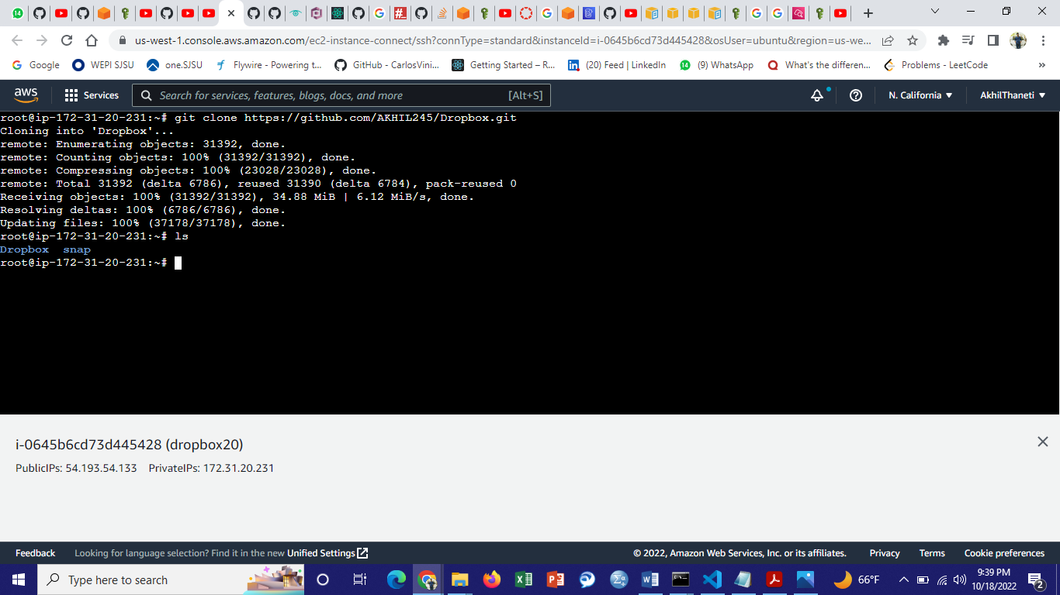

Cloning Dropbox project from Git.



Installing node to run the backend.

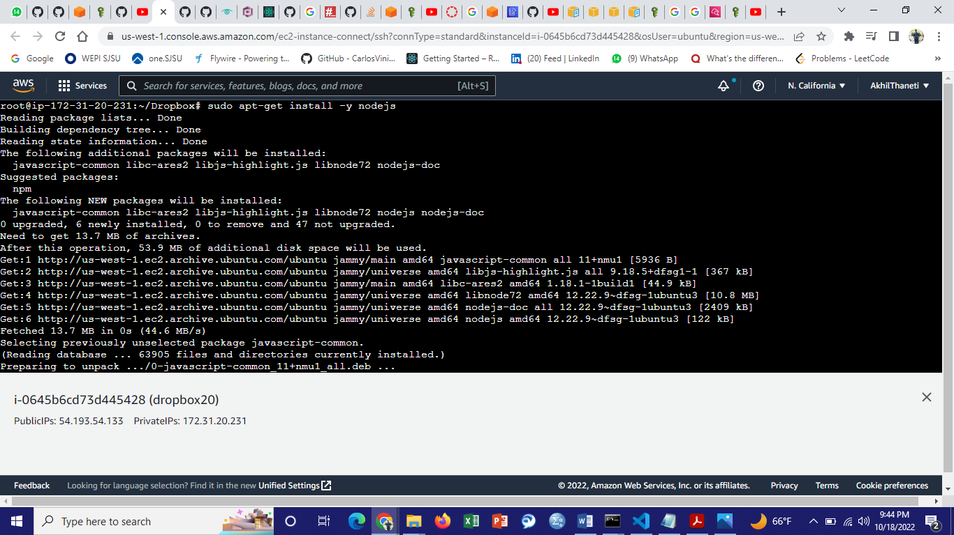

Installing nginx to deploy the frontend on nginx.

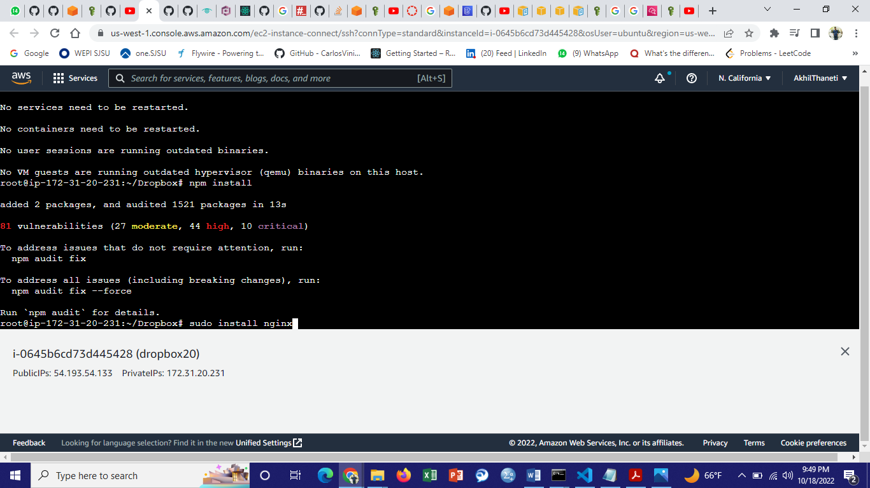

Building and deploying the frontend on nginx server.

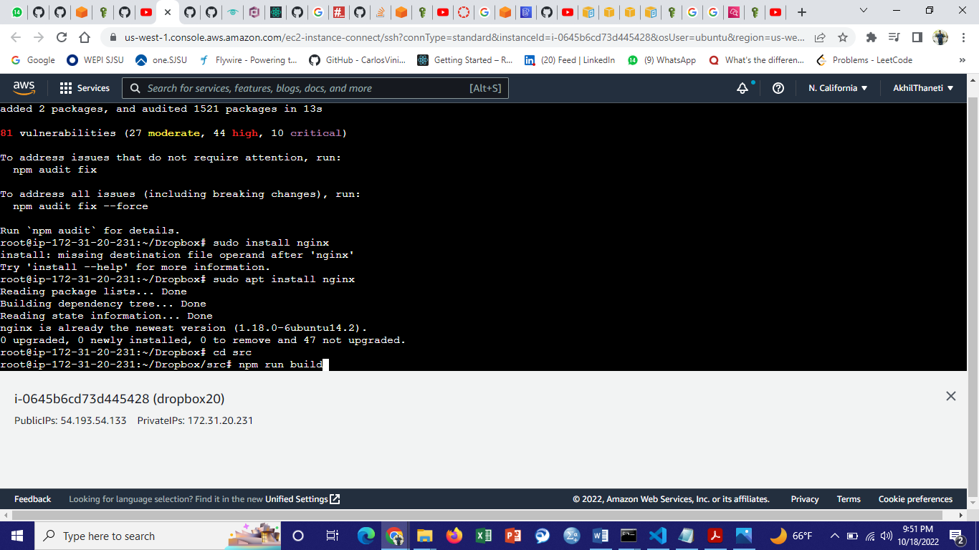

Created an elastic IP address and associating that to EC2 instance.

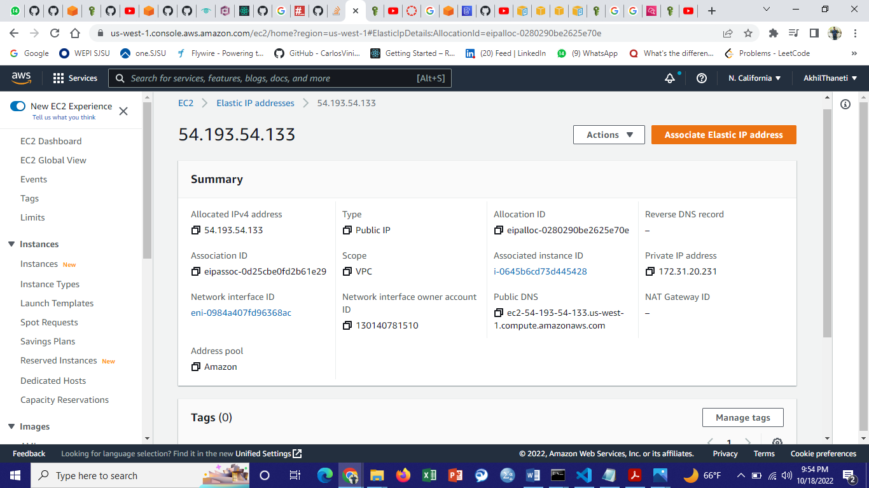

Created a load balancer to manage load between multiple instances.

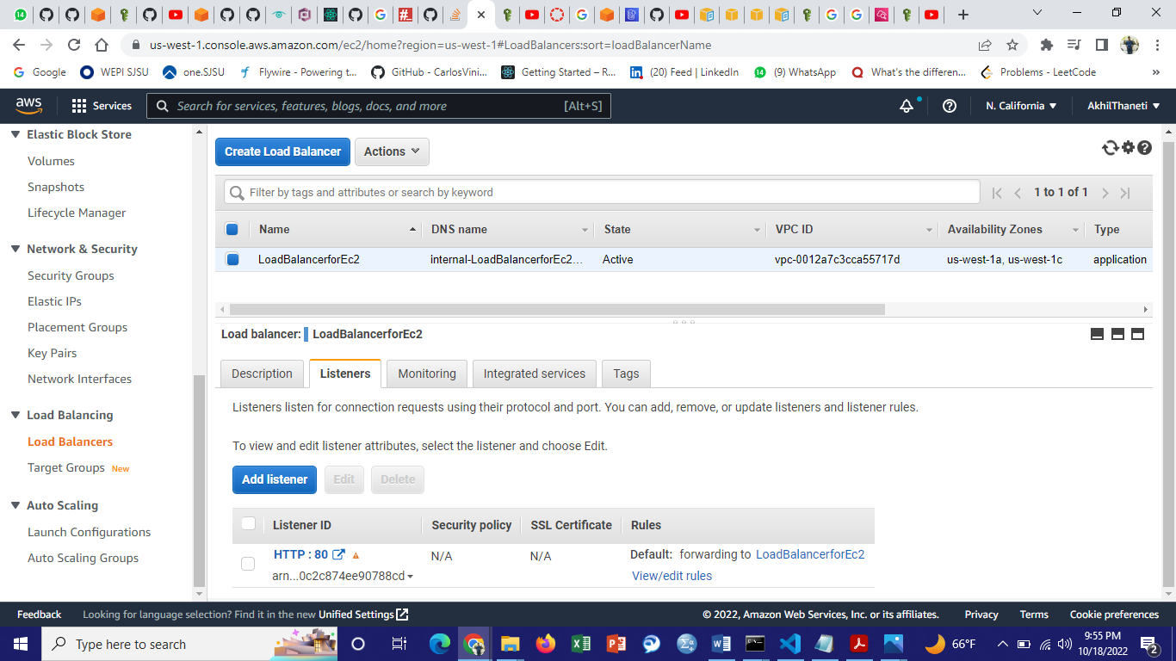

Created an Auto Scaling group.

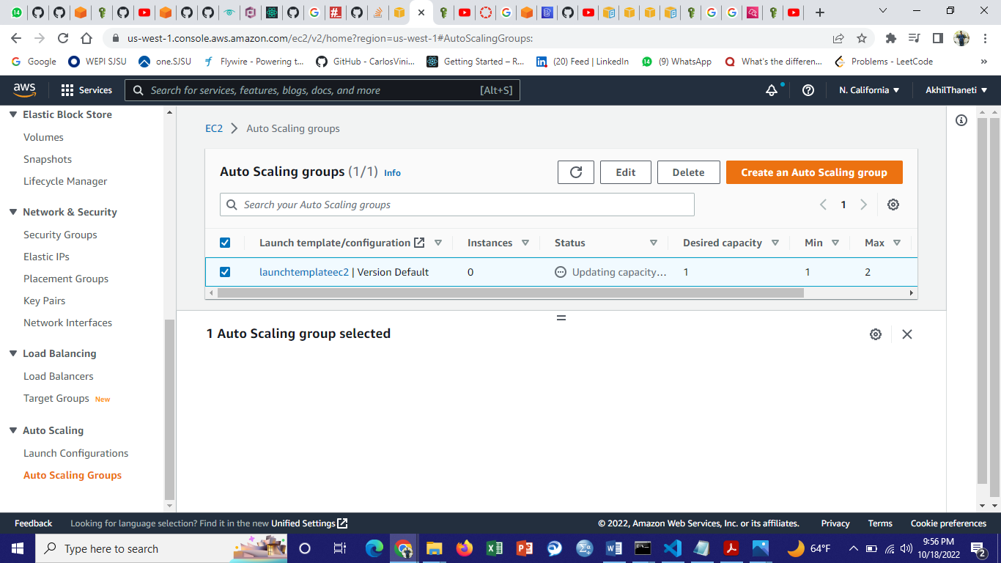

19) Creating a topic for SNS to send an email notification whenever the S3 bucket is uploaded/deleted with files.

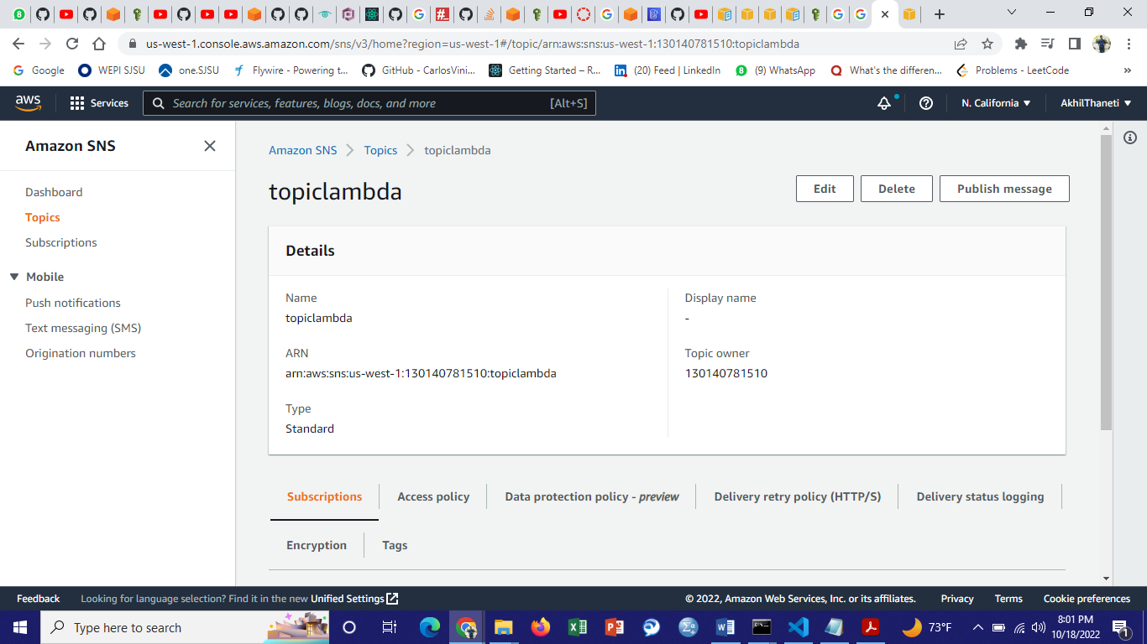

Created a subscription.

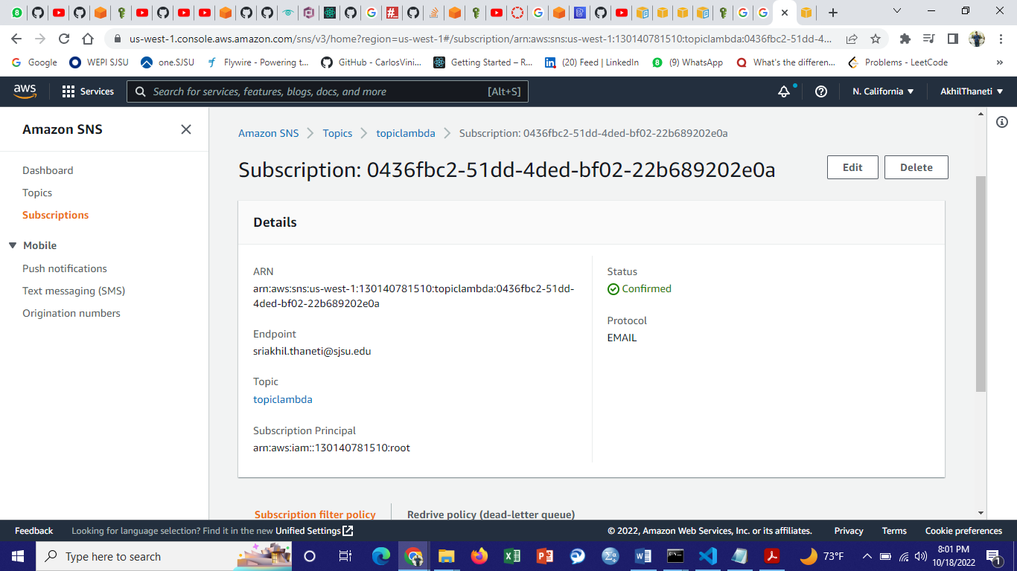

Creating a policy in IAM for SNS and providing the account id and the S3 bucket name in the policy.

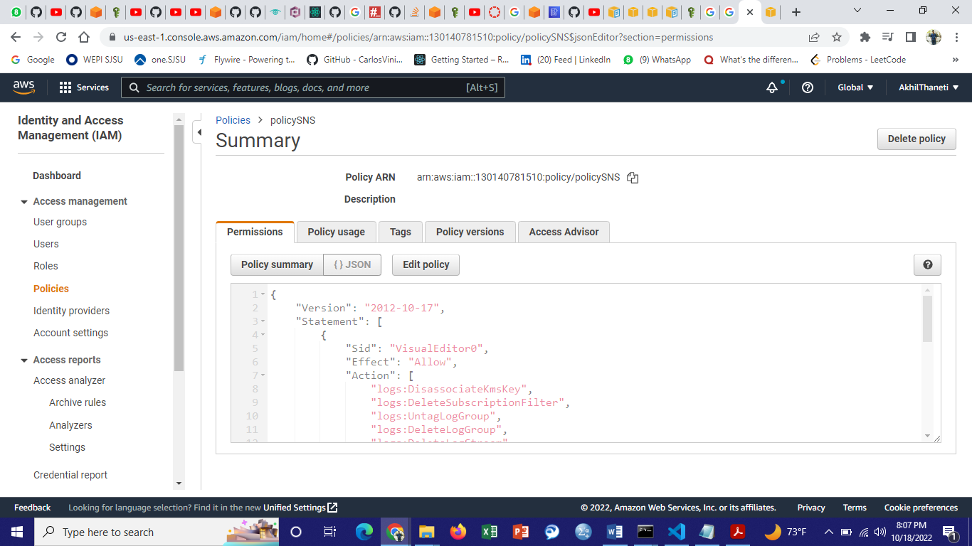

Creating a role in IAM and attaching the created policy for SNS.

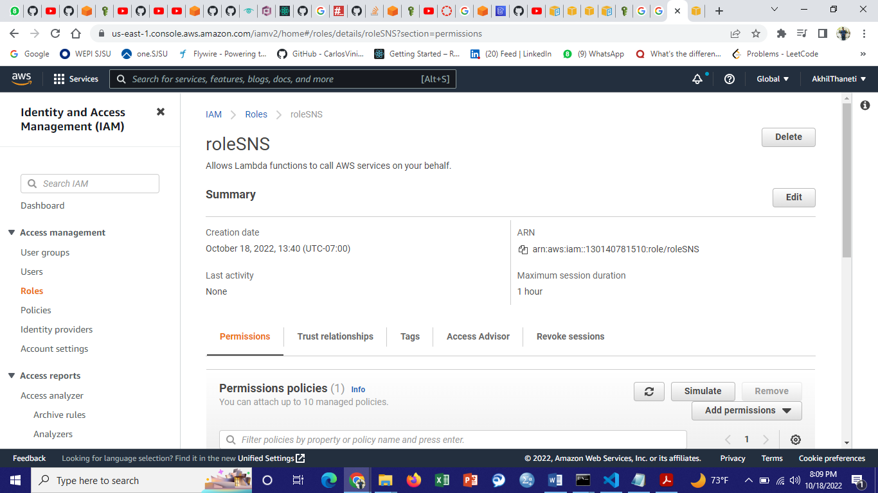

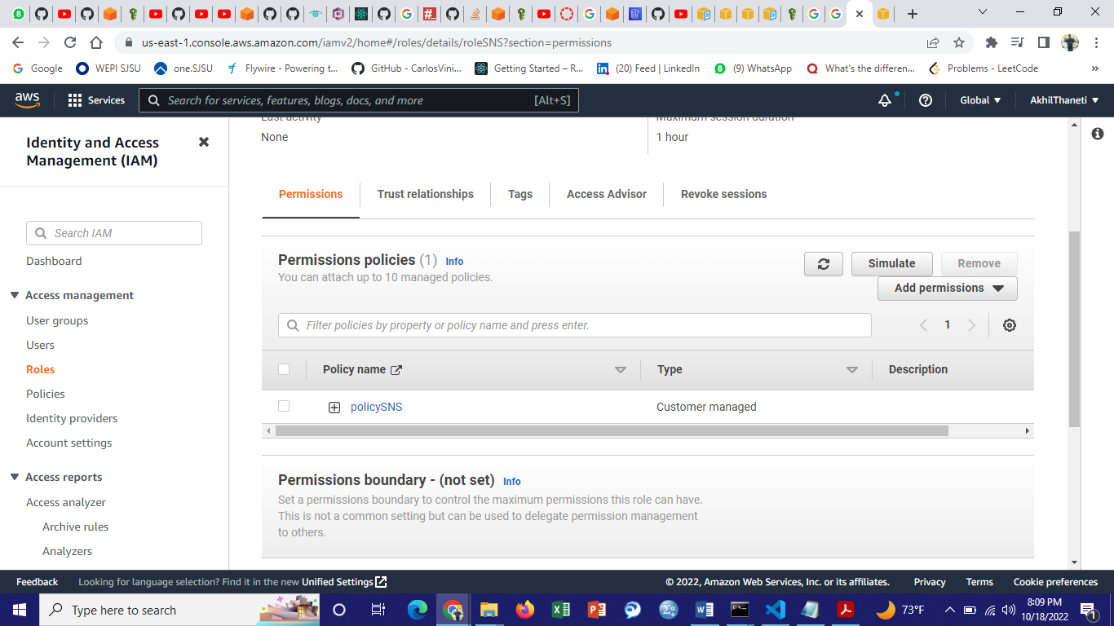

Created a lambda function to trigger SNS whenever the S3 is uploaded or deleted with files.

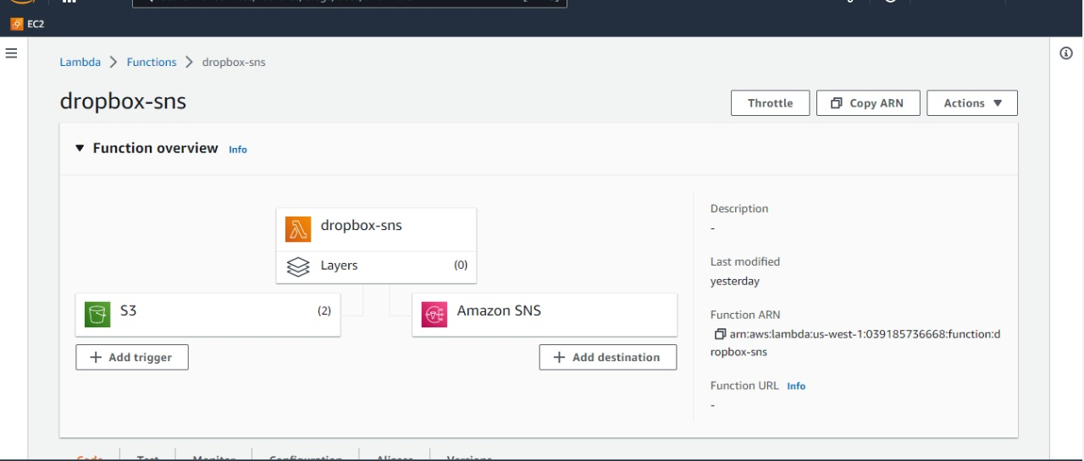

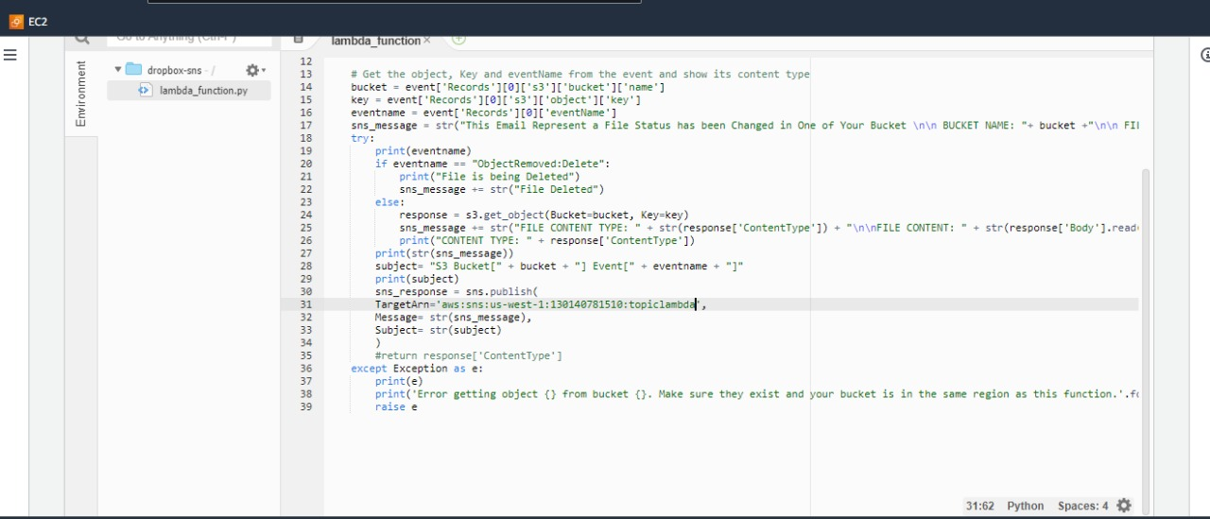

A notification has been sent when a file has been uploaded to the s3 bucket.

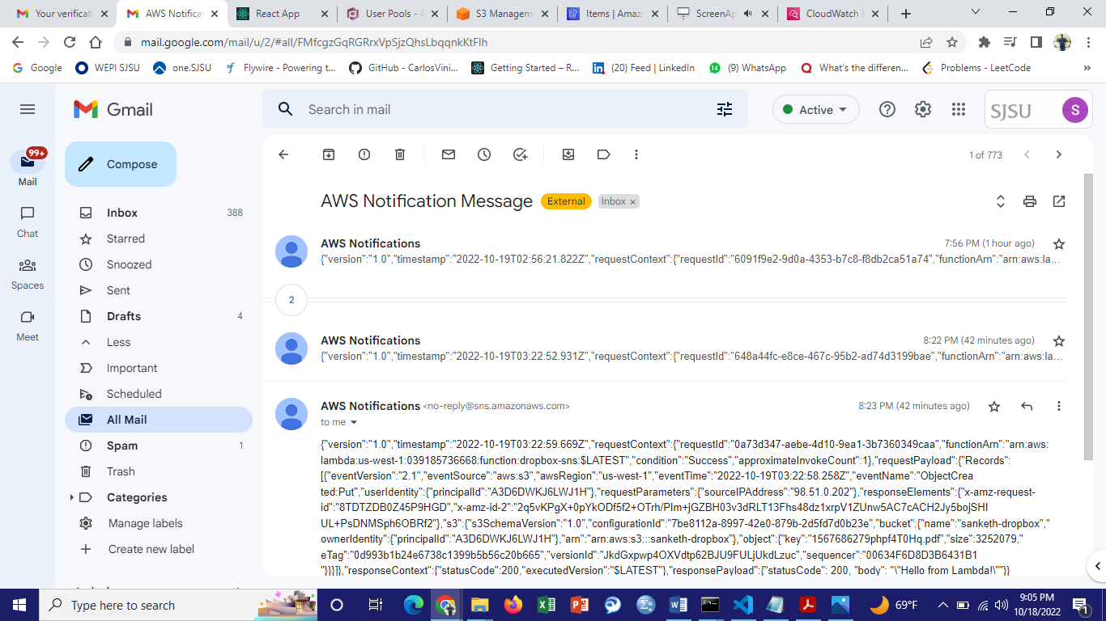

Attached AWS CloudWatch to AWS lambda to log the events when the lambda function is triggered.

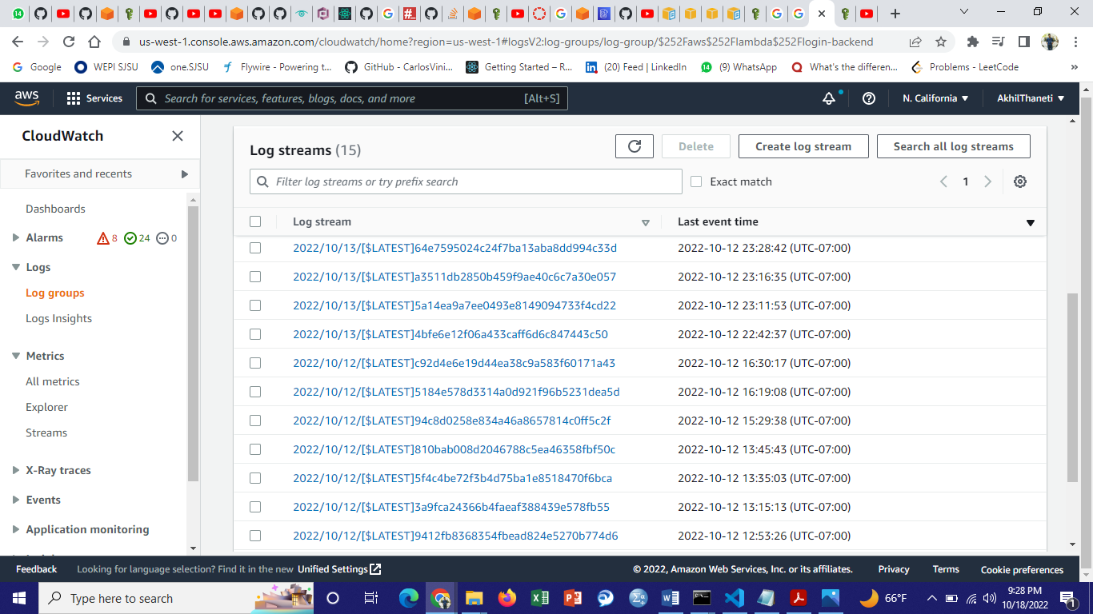

20) Below is the Url for the dropbox project that is pushed to Github.

<https://github.com/AKHIL245/Dropbox>

Below is the google drive link to watch the video of the Dropbox project.

<https://drive.google.com/file/d/1aom4XnR37_NXiZRMUH5RnqGCbnKZ3MyF/view?usp=sharing>